HK2  
Add Bootstrap 5

short line

Basant Mandal  
09th Aug, 2023

# Installation Guide

1. Setup :- Extract the zip folder in app/code
2. Run :- **php bin/magento module:enable HK2_AddBootstrap5**
3. Run :- **php bin/magento setup:upgrade** from your magento directory

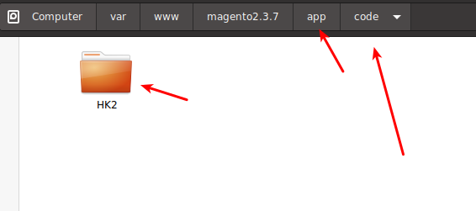

# 

# 

# Activation

Login to Magento Admin -> Add Bootstrap5 -> Configuration -> Enable - Yes

**Please clear the cache after enabling the option or changing the option**

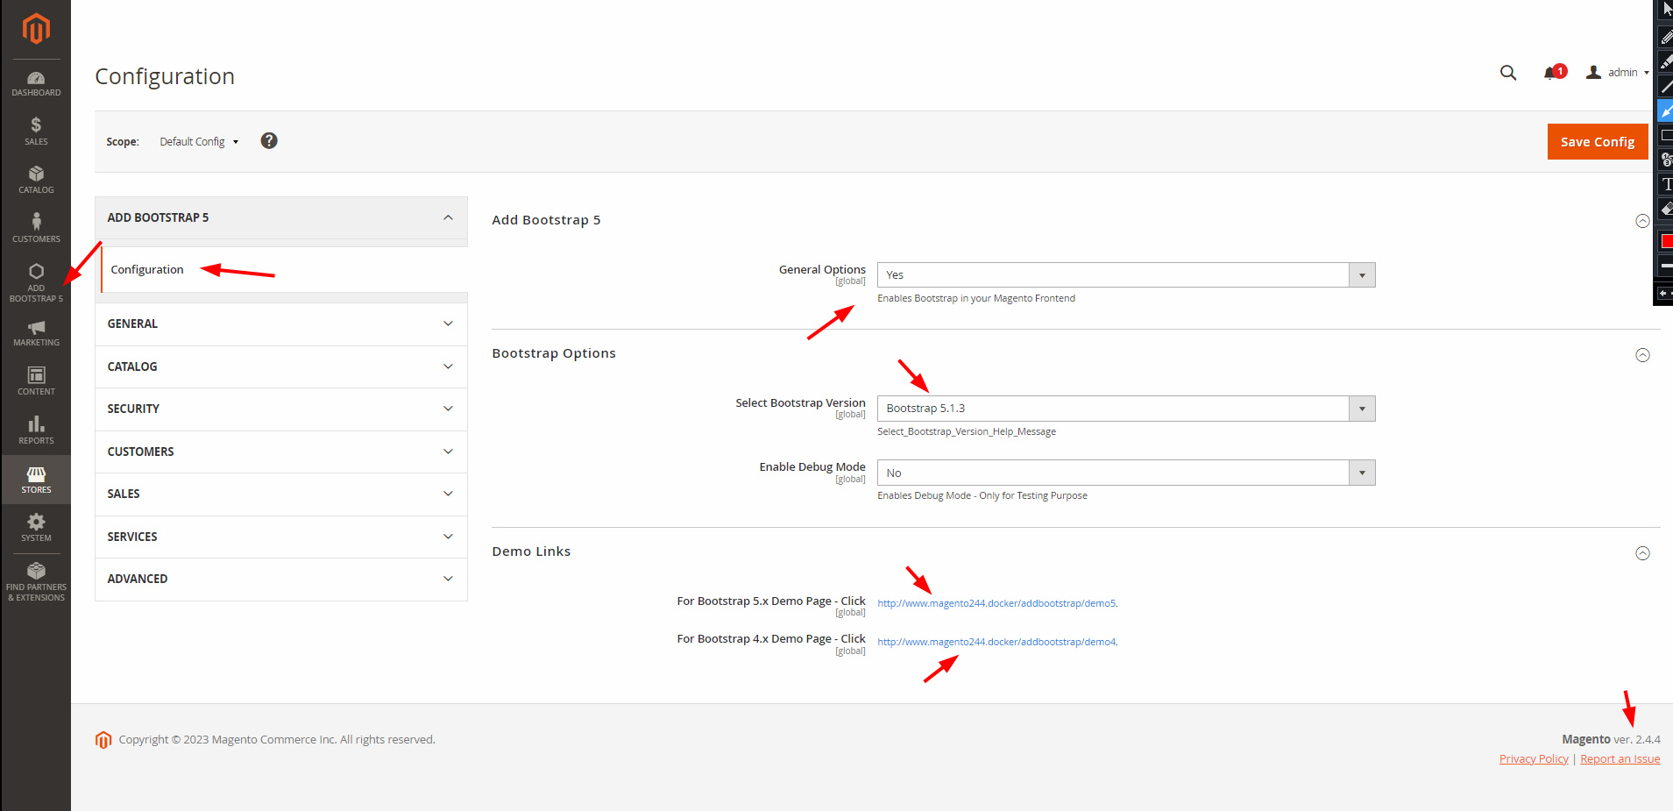

Once Installed, You can check in Magento Frontend - View Page Source (Right Click - View Page Source) & you can see Bootstrap 5 CDN is Added. Please check the screenshot in case you have any doubts.

**Note**:- This module enables Bootstrap CDN in Magento Frontend.

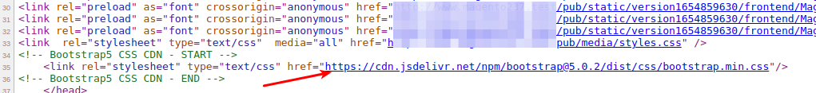

# 

# Testing

You can Test/Debug by clicking on the Demo Links.

**Login to Admin -> Click to Add Bootstrap 5 Option (Side Menu). Check the Screenshot**

If you selected Bootstrap 4, Click on Bootstrap 4 Link else Click on Bootstrap 5 Link



**Sample View will be available - Screenshot on Next Page**

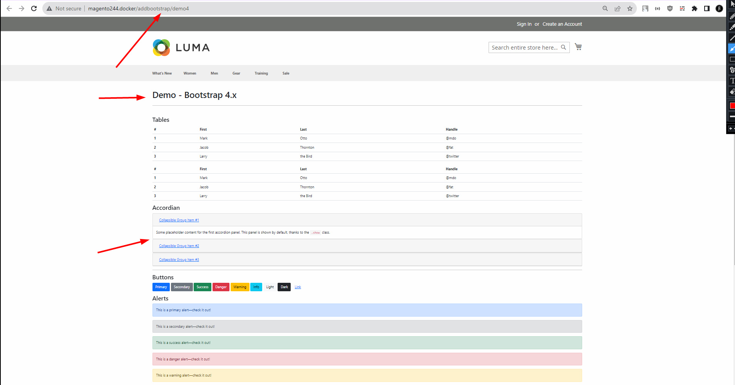

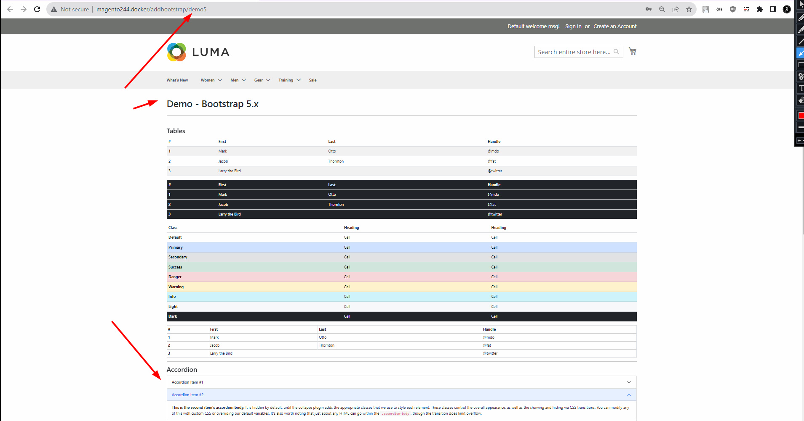

# Disclaimer

1. **Basant Mandal (HK2 - Hash Tag Kitto)** does not make any guarantees about the completeness, reliability and accuracy of this image or its related products. Any action you take upon the information you find here is strictly at your own risk.
2. **Basant Mandal (HK2 - Hash Tag Kitto)** will not be liable for any losses and/or damages in connection with the use of our website.

short line

# Support - Bug Reporting

For Bug reporting, Please open an issue at <https://github.com/basantmandal/HK2-Add_Bootstrap5/issues> on GitHub. When filing a bug remember that the better written the bug is, the more likely it is to be fixed.

In case of any feedback or any feature additions feel free to contact at [support@hashtagkitto.co.in](mailto:support@hashtagkitto.co.in)